**Week 3: Bank-Database**

create database bank_database;

use bank_database;

create table branch(

branch_name varchar(30) primary key,

branch_city varchar(40),

assets real

);

create table bank_account(

acc_no int,

branch_name varchar(40),

balance real,

primary key(acc_no,branch_name),

foreign key(branch_name) references branch(branch_name)

);

create table depositer(

customer_name varchar(30),

acc_no int,

primary key(customer_name,acc_no),

foreign key(acc_no) references bank_account(acc_no),

foreign key(customer_name) references bank_customer(customer_name)

);

create table bank_customer(

customer_name varchar(30) primary key,

customer_street varchar(40),

customer_city varchar(50)

);

create table loan(

branch_name varchar(30),

loan_number int primary key,

amount real,

foreign key(branch_name) references branch(branch_name)

);

desc branch;

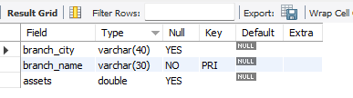

desc bank_account;

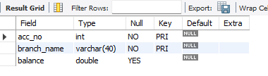

desc depositer;

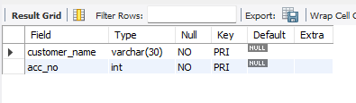

desc bank_customer;

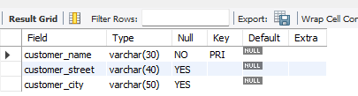

desc loan;

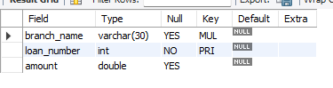

insert into branch

values('HDFC_Chamrajpet','Bengaluru',50000),('HDFC_AnandRaoCircle','Bengaluru',10000),('HDFC_ShivajiRoad','Mumbai',20000),('HDFC_ParliamentRoad','Delhi',10000),('HDFC_Jantarmantar','Delhi',20000);

select * from branch;

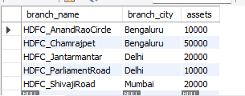

insert into bank_account

values(1,'HDFC_Chamrajpet',2000),(2,'HDFC_AnandRaoCircle',5000),(3,'HDFC_ShivajiRoad',6000),(4,'HDFC_ParliamentRoad',9000),(5,'HDFC_Jantarmantar',8000),(6,'HDFC_ShivajiRoad',4000),(8,'HDFC_AnandRaoCircle',4000),(9,'HDFC_ParliamentRoad',3000),(10,'HDFC_AnandRaoCircle',5000),(11,'HDFC_Jantarmantar',2000);

select * from bank_account;

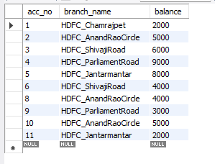

insert into bank_customer

values('Avinash','Bull_Temple_Road','Bangalore'),('Dinesh','Bannergatta_Road','Bangalore'),('Mohan','NationalCollege_Road','Bangalore'),('Nikil','Akbar_Road','Delhi'),('Ravi','Prithviraj_Road','Delhi');

select * from bank_customer;

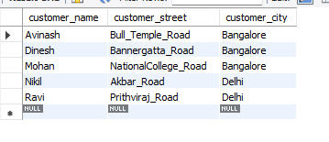

insert into depositer

values('Avinash',1),('Dinesh',2),('Nikil',4),('Ravi',5),('Avinash',8),('Nikil',9),('Dinesh',10),('Nikil',11);

select * from depositer;

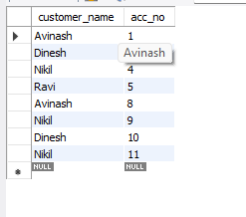

insert into loan

values('HDFC_Chamrajpet',1,1000),('HDFC_AnandRaoCircle',2,2000),('HDFC_ShivajiRoad',3,3000),('HDFC_ParliamentRoad',4,4000),('HDFC_Jantarmantar',5,5000);

select * from loan;

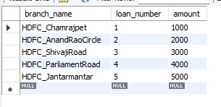

select branch_name,assets as assets_in_lacks from branch;

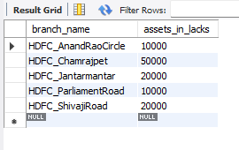

select d.customer_name,count(d.acc_no) from bank_account b,depositer d where b.acc_no=d.acc_no and branch_name='HDFC_AnandRaoCircle' group by customer_name having count(d.acc_no)>=2;



create view loan_sum as

select l.branch_name,sum(amount) from loan l group by l.branch_name;

select * from loan_sum;

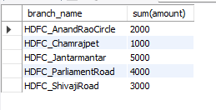

update bank_account set balance=(balance+1000)

where acc_no in (select d.acc_no from depositer d,bank_customer b where d.customer_name=b.customer_name and b.customer_city='Bangalore');

select * from bank_account;

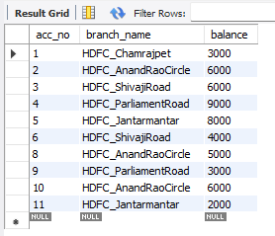

select customer_name from bank_account ba, depositer d

where branch_name in (select branch_name from branch

where branch_city = "Delhi") and ba.acc_no = d.acc_no

group by customer_name

having count(distinct branch_name) = (select count(branch_name) from branch

where branch_city = "Delhi");

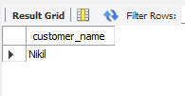

select customer_name from borrower where customer_name not in (select customer_name from depositer);

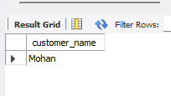

select distinct customer_name from depositer where customer_name in (select b.customer_name from borrower b,branch bh,loan l where l.loan_number=b.loan_number and l.branch_name=bh.branch_name and bh.branch_city='Bengaluru');

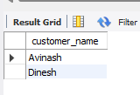

select br.branch_name,br.assets from branch br group by br.branch_name having br.assets>all(select b.assets from branch b where b.branch_city='Bengaluru');

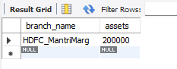

update bank_account set balance=balance+0.05*balance;

select * from bank_account;

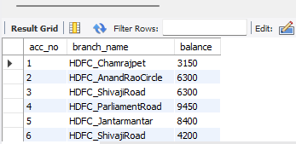

delete from depositer

where acc_no in (select acc_no from bank_account where branch_name in (select branch_name from branch where branch_city='Mumbai'));

delete from bank_account

where branch_name in (select branch_name from branch where branch_city='Mumbai');

select * from bank_account;

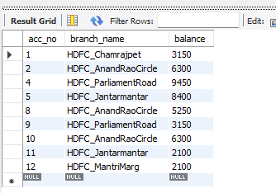

delete from depositer

where acc_no in (select acc_no from bank_account where branch_name in (select branch_name from branch where branch_city='Bengaluru'));

delete from loan

where branch_name in (select branch_name from branch where branch_city='Bengaluru');

delete from bank_account

where branch_name in (select branch_name from branch where branch_city='Bengaluru');

delete from branch

where branch_city='Bengaluru';

select * from branch;

